 Corporate HSE Governance

Date: 25-07-2017

Vesta Oil BV has an on-going commitment to continuously protect people and the environment, whilst improving the quality of its services.

Ensuring good health, operational safety, environmental protection, quality enhancement, customer satisfaction and community well-being are always at the forefront of Vesta’s Oil BV corporate mission.

In order to achieve this, Vesta Oil BV acts in accordance with the following principals:

* Identifying & analysing potential hazards and implementing measures to prevent, control and restrict the associated risks and minimize risks to people and environment during the entire life cycle of our assets.
* Providing a safe working environment for all staff, contractors and third parties with adequate facilities and appropriate protective equipment.
* Developing, building, maintaining and operating our Oil BV in such manner to minimize risks to people and environment.
* Maximizing the reduction of emissions to land, water and air and also limiting the usage of energy and water.
* Complying with all local applicable legislation, applying appropriate standards when effective and required.
* There is a Vesta wide HSE management system in place in which each terminal operates in accordance to. With this management system, targets are set and performances are monitored and benchmarked to achieve continuous improvements.
* Providing training and education to all employees supported by international standards and best practices.
* Ensuring total preparation for a quick and efficient response to emergency situations at all times, minimizing the potential impact of incidents should they occur.
* Promoting HSE management in all Vesta companies, acting professional and leading by example.
* Ensuring staff and external parties at the terminal work together in a safe and environmental friendly manner and are aware of potential unsafe actions or situations.

Execution of the HSE governance and all related activities is the responsibility of all Vesta employees. Vesta Oil BV B.V.

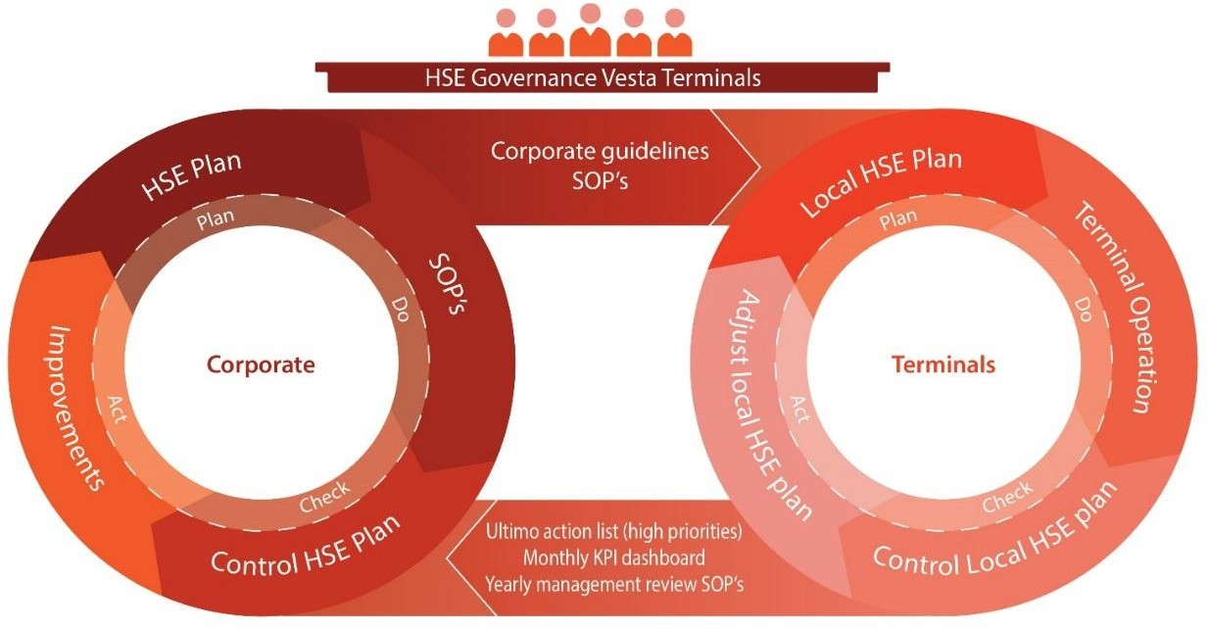Martijn Notten

Chief Executive Officer